**Joins and Unions**

**Demo Document**

**Statement:**

Suppose you are given Student Personal Information and Students Academic Information and you are asked to create a tableau report on showing Students performance in math, reading and writing test based on Gender.

(Use Student personal Information.xlsx and Student Academic Information.xlsx)

**Solution:**

**Joins in Tableau:**

Tableau Joins play a very vital role in designing reports. Joins are used to link different datasets from different sources, provided both have one common field.

We are given a data source which has data sheets:

1. Student Personal Information

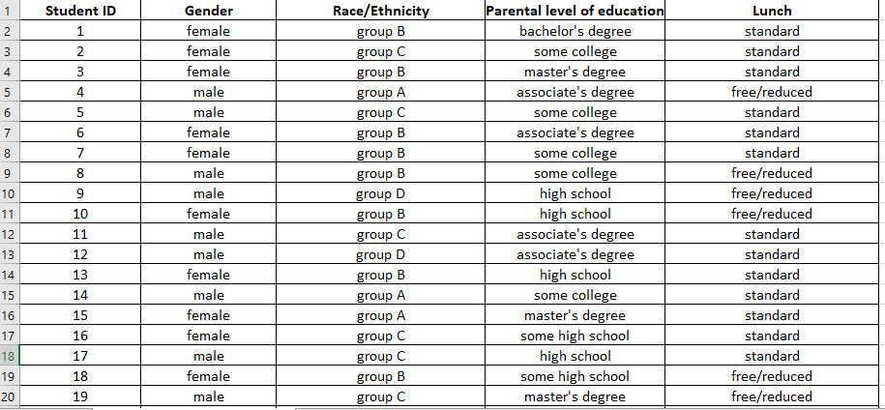

1. Student Academic Information

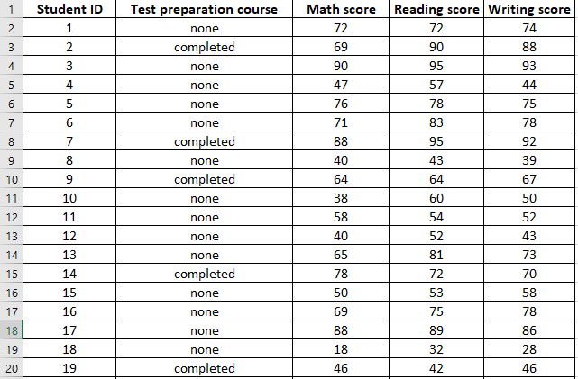

Now given the datasets, we need to create a Tableau report to visualize the performance of students in the tests based on gender.

**Step 1:** Click on Excel

**Step 2:** Select “Student Performance Information” and click on Open

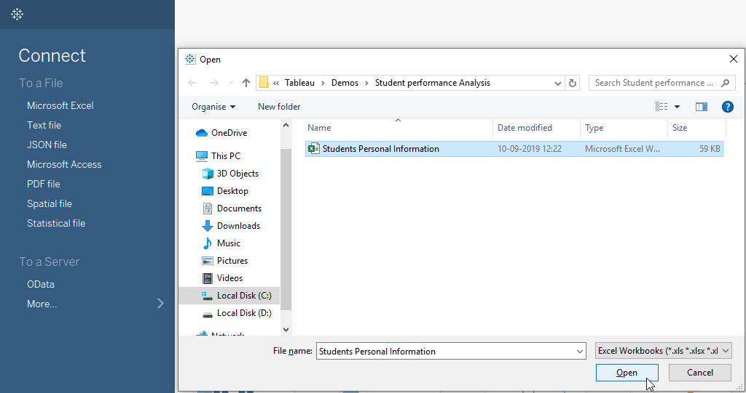

**Step 3:** Drag the “Student Personal Information” sheet and drop it in the flow pane.

**Step 4:** Drag “Student Academic Information” and drop it in the flow pane.

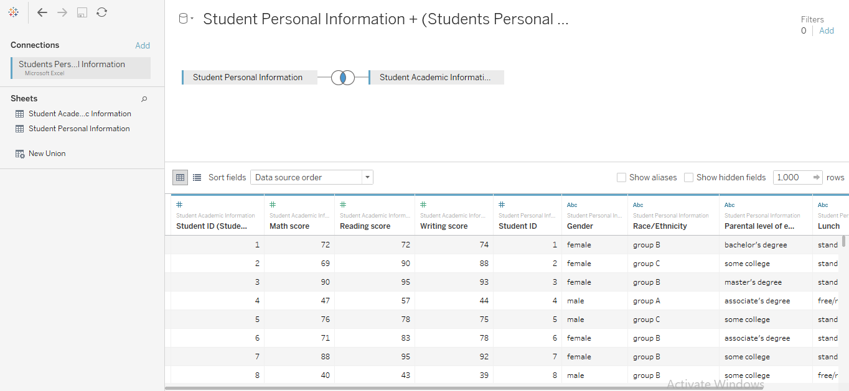

**Step 5:** Combine both the data sources using inner join, and click on Sheet 1.

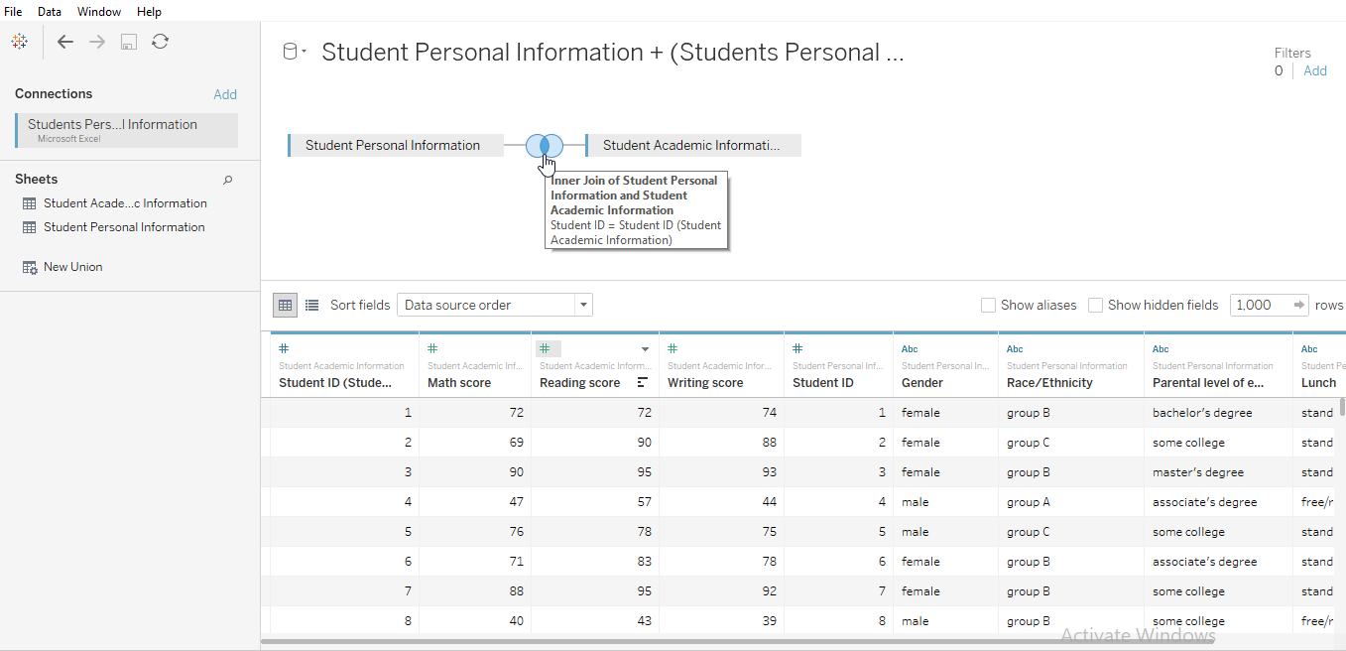

**Step 6:** Drag “Gender” from Dimensions to the column shelf and “Math score”, “Reading score” and “Writing score” from Measures to row shelf. Lastly, add “Measure Values” to Color shelf (Marks Card).

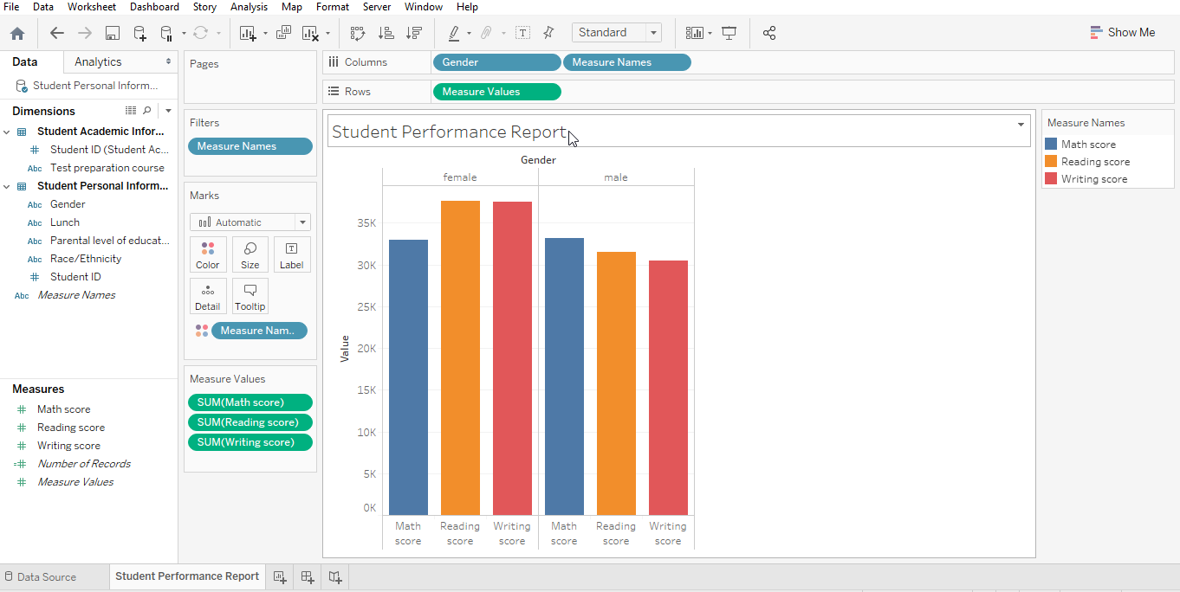

**Step 7:** Drag “Race/Ethnicity”, “Test Preparation Course” and “Student ID” to **Detail Shelf** and “Measure Names” to **Color shelf**

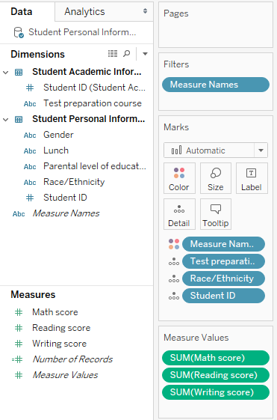

**Step 8:** Create a bar chart by dragging

* Gender and Measure Names (Maths, Reading and Writing score) in column shelf
* Measure values(Maths, Reading and Writing score) in row shelf
* Test Preparation Course, Race and Student ID to Details Shelf (Marks card)

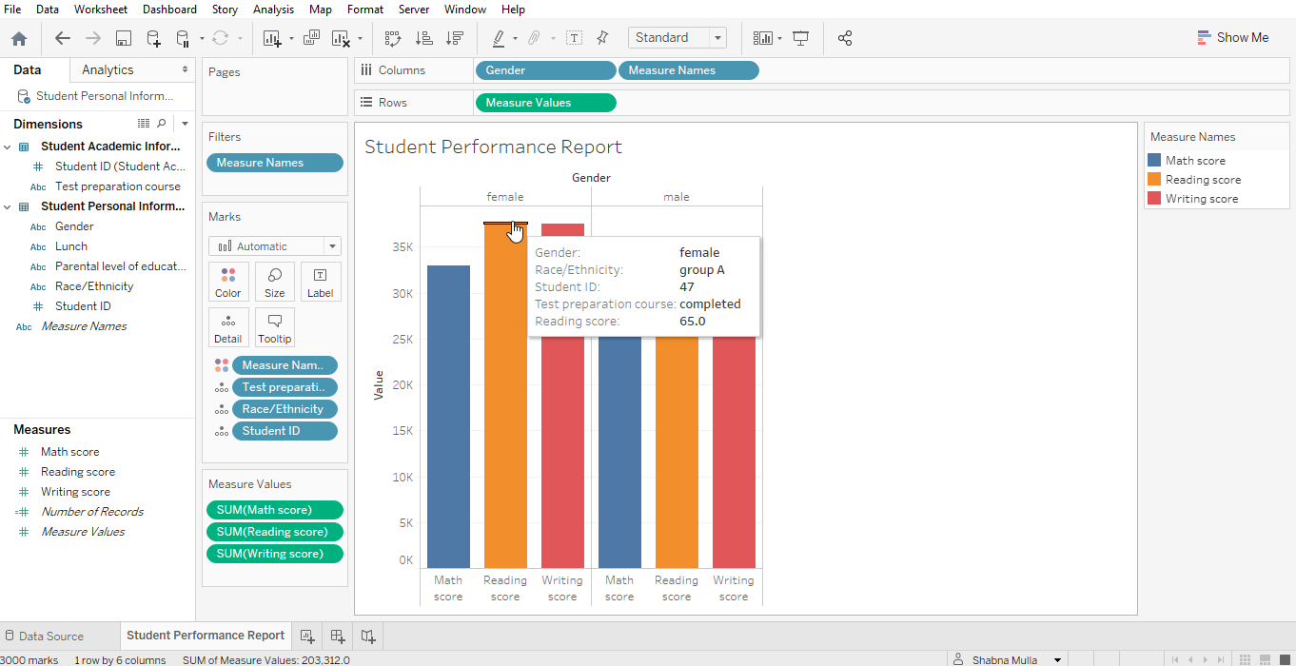

The chart shows the scoring of students in different tests based on Gender.